**17** Microlevel of the LCC

Data Path

C Bus Register A Bus B Bus

16

Bank

16

r0

. . . .

. . . .

. . . .

r30

r31

ALU

16

Main Memory Interface

Memory data bus

Main Memory Register Bank

Memory address bus

mar

mir

wr rd mdr rd wr

Specifying the ALU Operation

ALU

mir

alu

4

Complete Microlevel Structure of the LCC

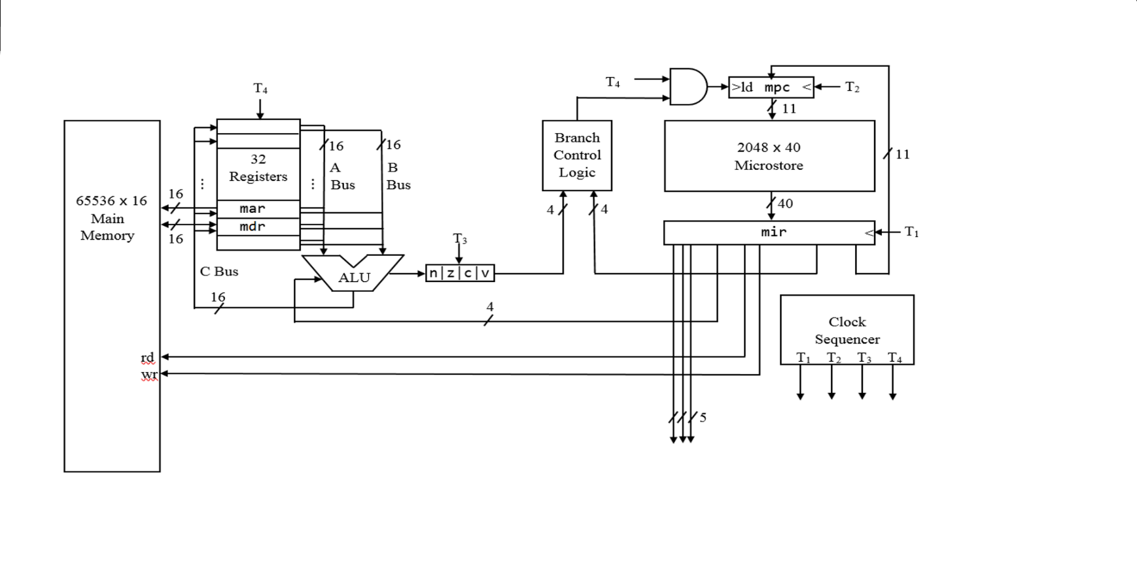

Clock Sequencer

T1 . . .

T2 . . .

T3 . . .

T4 . . .

Binary and Symbolic Microcode

a.pc nop c.mar ; load mar with contents of pc

a.pc add b.1 c.pc rd ; read from address in mar and incr pc

A binary microinstruction consists of several fields, some of which are the a, b, c, alu, and rd fields:

a b c alu rd

Microinstruction Format

A amux B bmux C cmux ALU u rd wr cond addr

5 1 5 1 5 1 4 1 1 1 4 11 width

Field

A Specifies register that inputs to the A multiplexer

amux Controls A multiplexer:

amux = 0 then A field in mir drives A decoder

amux = 1 then A field in ir drives A decoder

B Specifies register that inputs to the B multiplexer

bmux Controls B multiplexer:

bmux = 0 then B field in mir drives B decoder

bmux = 1 then B field in ir drives B decoder

C Specifies register that inputs to the C multiplexer

cmux Controls C multiplexer:

cmux = 0 then C field in mir drives C decoder

cmux = 1 then C field in ir drives C decoder

alu Specifies ALU operation:

F3 F2 F1 F0 Mnemonic Output Flags Set

0 0 0 0 (0) nop left

0 0 0 1 (1) not ~left nz

0 0 1 0 (2) and left & right nz

0 0 1 1 (3) sext left sign ext, (rt = mask) nz

0 1 0 0 (4) add left + right nzcv

0 1 0 1 (5) sub left − right nzcv

0 1 1 0 (6) mul left * right nz

0 1 1 1 (7) div left / right nz

1 0 0 0 (8) rem left % right nz

1 0 0 1 (9) or left | right nz

1 0 1 0 (10) xor left ^ right nz

1 0 1 1 (11) sll left << right (logical) nzc

1 1 0 0 (12) srl left >> right (logical nzc

1 1 0 1 (13) sra left >> right (arithmetic) nzc

1 1 1 0 (14) rol left << right (rotate) nzc

1 1 1 1 (15) ror left >> right (rotate) nzc

u User n, z, c, v flags used instead of system flags

rd Initiates memory read from address in mar

wr Initiates memory write of data in mdr to address in mar

cond Specifies branch condition:

Mnemonic Branch if Branch on

0 nobr never

1 zer z = 1 zero or equal

2 !zer z = 0 not zero or not equal

3 neg n = 1 negative

4 !neg n = 0 not negative

5 cy or < c = 1 less than (unsigned cmp)

6 !cy or >= c = 0 grt or eq (unsigned cmp/overflow)

7 v v = 1 signed overflow

8 pos n = z positive

9 lt n != v less than (signed cmp)

10 le n != v or z = 1 less than or equal (signed cmp)

11 gt n = v and z = 0 greater (signed cmp)

12 ge n = v greater than or equal (signed cmp)

13 <= c = 1 or z = 1 less than or equal (unsigned cmp)

14 > c = 0 and z = 0 greater than (unsigned cmp)

15 br always

addr branch-to address

In the enhanced LCC (see Chapter 10 in “Constructing a Microprogrammed Computer Second Edition”),

* each microinstruction has a mmux bit in the rightmost position that controls the mpc multiplexer
* the mpc is 12 bits wide
* the addr field in each microinstruction is 12 bits wide
* microstore can hold up to 4096 microinstructions.

Register Names

Reg Num Name Initial Contents Function

0 r0 or ac accumulator register

1 r1

2 r2

3 r3

4 r4

5 r5 or fp frame pointer register

6 r6 or sp stack pointer register

7 r7 or lr link register

8 r8 or 3 0x0003

9 r9 or 4 0x0004

10 r10 or 5 0x0005

11 r11 or omask 0xf000 opcode mask

12 r12 or cmask 0x01e0 count mask (for shifts)

13 r13 or bit5 0x0020

14 r14 or bit11 0x0800

15 r15 or bit15 0x8000

16 r16 or m3 0x0007

17 r17 or m4 0x000f

18 r18 or m5 0x001f

19 r19 or m6 0x003f

20 r20 or m8 0x00ff

21 r21 or m9 0x01ff

22 r22 or m11 0x07ff

23 r23 or m12 0x0fff

24 r24 or ir machine instruction register

25 r25 or pc program counter register

26 r26 or temp

27 r27 or dc decoding register

28 r28 or 1 0x0001 constant 1

29 r29 or mar memory address register

30 r30 or mdr memory data register

31 r31 or 0 0x0000 constant 0 (read-only register)

; Microcode for Tiny Instruction Set t.sm

;==============================================

; Fetch machine instruction, increment pc

fetch: a.pc c.mar

a.pc add b.1 c.pc rd ; sim handles trap instructions here

;==============================================

; Decode instruction

a.mdr add b.0 c.ir neg@ld ; mov mdr to ir, set flags, br neg

a.ir sll b.1 c.dc neg@add ; sh left 1 pos, set flags, br neg

a.dc sll b.1 c.dc neg@sub ; sh left 1 pos, set flags, br neg

br@ldi ; first 3 bits 0 so ldi inst

;==============================================

; Interpret machine instruction

; ==========================================

ld: a.ir and b.m12 c.mar ; get x field, move to mar

rd ; read from main memory

a.mdr nop c.r0 br@fetch ; move mdr to r0, br to fetch

; ==========================================

add: a.ir and b.m12 c.mar ; get x field, move to mar

rd ; read from main memory

a.r0 add b.mdr c.r0 br@fetch ; add mdr to r0, br to fetch

; ==========================================

sub: ; microcode missing here

; ==========================================

ldi: ; microcode missing here

Assembling Microcode

micro t.sm (assembles microcode to t.m)

tiny ttest.a (assembles ttest.a program to ttest.e)

sim ttest.e (runs ttest.e program using t.m)

tiny Assembler Version 1.0 Sat Nov 05 11:39:05 2022

x

­Makes sim use t.m microcode

Header

t

A 0000

A 0003

A 0006

C

Loc Code Source Code

; test program for t.sm microcode ttest

0000 800d ld a ; load r0 from a

0001 f002 dout ; display r0 (displays 2)

0002 f001 nl ; move cursor to next line

0003 400e add b ; add word at b to r0

0004 f002 dout ; display r0 (displays 5)

0005 f001 nl ; move cursor to next line

0006 200d sub a ; subtract word at a from r0

0007 f002 dout ; display r0 (displays 3)

0008 f001 nl ; move cursor to next line

0009 1007 ldi 7 ; load immediate value 7 into r0

000a f002 dout ; display r0 (displays 7)

000b f001 nl ; move cursor to next line

000c f000 halt

000d 0002 a: .word 2

000e 0003 b: .word 3

Evaluation of the Instruction Set Architecture of the LCC

* The calling sequence for a function performs pushes and a pop. For that we have the push and pop instructions that work with the sp register. We also have the sub instruction to allocate local variables on the stack by subtracting a positive number from the sp register and the add instruction to remove items from the stack by adding a positive number to the sp register. For example, to allocate a word on the stack, we use

sub sp, sp, 1

To deallocate three parameters that were previously pushed onto the stack by the calling sequence of a function, we use

add sp, sp, 3

* To access parameters and dynamic local variables on the stack, we have the fp register that provides a fixed base address for the ldr and str instructions. For example, to load r0 with the first parameter in a function (which has an offset of 2 with respect to the base address in the fp register), we use

ldr r0, fp, 2

* Getting the address of variables is easy. For global and static local variables, we have the lea instruction. For parameters and dynamic local variables, we have the add instruction. For example, to load the address of the global variable x into r0, we use

lea r0, x

To load the address of a local variable at the offset -2, we use

add r0, fp, -2

* Dereferencing pointers is easy. We use a ld or ldr instruction to get the pointer and then a ldr or str to dereference the pointer. For example, to load r0 with the word pointed to by the local variable whose offset is -1, we use

ldr r0, fp, -1 ; get the pointer

ldr r0, r0, 0 ; dereference the pointer

* Accessing the fields of a struct is easy. We can easily access any of its fields by specifying the appropriate offset in a ldr instruction. For example, if r0 contains the address of a struct, to load r1 with the field at offset 5, we use

ldr r1, r0, 5 ; load r1 with field at offset 5

* Calling a function both via the address of the function or via its name is easy. For example, to call the function whose address is in r0, we use

blr r0

To call the f function by name, we use

bl f

* We can zero out, set to 1, flip, and test individual bits within a word using the bitwise instructions (and, or, and xor).